**Brooklyn torah gazette**

**For parshas vayeira 5780**

Volume 4, Issue 9 (Whole Number 161) 18 Cheshvan 5780/ November 17, 2019

**Printed L’illuy nishmas Nechama bas R’ Noach, a”h**

For a free subscription, please forward your request to [***keren18@juno.com***](mailto:keren18@juno.com)

**How to Educate Kids of**

**All Ages to Not Make**

**Candy their Main Meal**

**By Daniel Keren**



(“The Munchkies Adventure on Sweet Island” written and illustrated by Devorah Benedict, 87 pages, Feldheim Publishers, 2019)

One of the biggest challenges for any parent is to try and get their children to eat healthy meals. And if you have gone to any grocery store or supermarket, you can understand why with all the colorful eye-catching displays of candies and other rich sweets that anyone wouldn’t be addicted to a heavy diet of such caloric catastrophes. But then once your child’s dentists tells you how many cavities your little tzadik or tzadekes has, you will want to get a copy of Devorah Benedict’s new book on how to wean your child to a more healthy menu.

**An Incredibly Talented Illustrator**

Mrs. Benedict is a successful author of a dozen books for children on important topics including “I Want a Friend” that offers children and their parents practical tools for social success. Not only does she carefully research the topics, but also Mrs. Benedict is an incredibly talented illustrator whose stunning depictions make the reader and listener grasp the reality of the danger that can confront anyone who eats too much candy and sweets.

The author lives in Israel and of course the immediate problem of how to get our children (and of course ourselves as adults and role models) to eat property has the endorsements of numerous pediatricians, nutritionists and dieticians.

**Simply Worded Text will Appeal**

**To Parents & Children Alike**

Ortal Arieli endorses the message of “The Munchkies Adventure on Sweet Island” by declaring wholeheartedly that “This enchanting book is filled with beautiful, brightly-colored illustrations and helpful information to teach kids about health. The text is simply worded and will appeal to parents and children alike.”

A simple prayer that the author includes in her new book is “Thank You, Hashem, for enabling me to live a healthy life in Your wonderful world!” Isn’t it so sad that more and more children and adolescents (estimated between 25% and 40% are obese or severely overweight from eating too much, and often the wrong unhealthy foods) are in danger of becoming diabetic, with the terrible results that their ability to live a normal healthy and enjoyable life without needing insulin is being taken away from them.

**A Life-SavingBook for Kids of All Ages**

At the start of her important and perhaps life-saving book for kids of all ages, Mrs. Benedict offers various tips to encourage one’s children to eat healthy including being a personal example by showing one’s kids that their parents have chosen to eat fruits and vegetables instead of too much munching on junk food; have regular family mealtimes and keep your kitchen stocked with a variety of healthy foods.

The author takes the reader on a voyage of discovery to a little island way out in an unnamed ocean where little child-like rosy-cheeked creatures called Munchkies live in a land they call Sweet Island. What can happen when the islanders give in to their uncontrolled cravings for sweets galore?

“The Munchkies on Sweet Island loved to eat sweets. At every meal and between meals too, all they ate was sweets: lollipops, chocolate, marshmallows and ice cream. The Munchkies ate while they played, and even when it was time to go to sleep, they curled up in bed with sugary snacks.”

**The Danger of Eating Too Much Sugar**

To drive home the lesson of the danger of eating too much sugar, the author devotes a two page section to the topic of sugar that explains the addictive nature of this sweet substance and also the very serious problem of how treats full of sugar weaken the immune system that unfortunately results in one’s child getting sick more often and obviously missing out on important days of going to school and learning important topics.

Hope comes in the unexpected arrival from Pepper, a Munchkee from another land who is shipwrecked onto Sweet Island and is appalled by what he sees and feels compelled to warn the islanders of the great risk they are facing.

**The Value of Healthy Fresh Vegetables and Fruits**

Other important topics that Mrs. Benedict explains to her readers are the value of healthy fresh vegetables and fruits; the correct inclusion in one’s diet of carbohydrates, protein, calcium, good fats (and the avoidance of unhealthy fats,) and the value of substituting water for sweets drinks; as well as incorporating exercise and properly brushing one’s teeth and sleeping well. And, of course, let’s not forget the significance of proper hygiene as the author notes in her colorful and very informative book.

“The Munchkies Adventure on Sweet Island” by Devorah Benedict is a pleasant way to address serious problems and correct them if need be. It is never too late to correct a terrible nutritional addiction. And by reading this book to your kids you will be doing your family (and most probably yourself too) a great favor and avoid the tragedy of your children blaming you years later for their terrible health problems.

Mrs. Benedict’s latest book for children can be found in Jewish bookstores or by contacting the publisher by clicking [www.feldheim.com](http://www.feldheim.com) or calling (800) 237-7149. It’s a great gift not only for parents, but for grandchildren, nephews or nieces or for any child you care about.

*Reprinted from the November 1, 2019 edition of The Jewish Connection.*

**How Can I Help You?**

**By** [**Rabbi Moshe Meir Weiss**](https://www.jewishpress.com/author/rabbi-moshe-meir-weiss/)

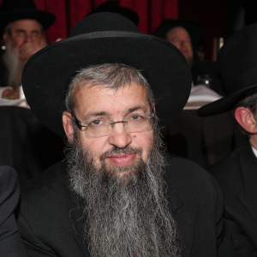

Once again, I turn my reader’s attention to the Orchos Chaim l’HaRosh. In Number 68, he declares that for a successful life, “Tzedek tzedek tirdof,” one should vigorously pursue acts of charity and kindness.

Here, the Rosh provides us with an insight on how a Torah Jew is different from a contemporary secular American. In the non-Torah world, one pursues every opportunity for pleasure and fun. The proliferation of travel brochures, food advertising, the movie industry, music and computer games, romance and mystery novels, is the stuff that the average American is busy pursuing.

The Rosh educates us, citing the aforementioned verse in Devarim that we on the other hand should seek every opportunity to help out our fellow man. As a way to persuade us, he cites the reward that one who pursues charity, “Yimtza chaim, tzedakah, v’chavod,” will find life, get more charitable opportunities, and honor.

It is my humble opinion that the numeration for each of the 154 recommendations in this sefer is not random. This lesson, Number 68, is the gematria of ‘chaim,’ life.  We are taught, “Tzedaka tatzil m’maves – Charity saves one from death.”

The sequel of the verse “Tzedek tzedek tirdof” is “Lema’an tichya – In order that you should live.” The reason why charity is rewarded with life, man’s most precious commodity is as follows.

When we give $100 to charity and we earn $50 an hour, we are actually giving away two hours of our life. Since Hashem pays measure for measure, he rewards us in his grand way with a much greater addition of life.

The number 68 is also the gematria of chacham, a wise person. We are taught, “Eizahu chacham? Haro’eh es hanolad – Who is wise? He who can look ahead.” The giver of charity shows a maturity of foresight. Most people have a hard time giving away their hard-earned cash for that which does not promise them immediate gratification.

As the Gemora teaches us at the end of the first perek of Baba Kamma, “Ein zeria ela tzedakah – The term ‘planting’ (homiletically) refers to charity,” like the farmer who spends thousands of dollars on seeds and then just buries them in the earth without any immediate return. So too, one parts with his precious cash and doesn’t see any instant benefit. But, the wise person knows that the only money which is his for all eternity is that which he gives away to help others.

The Rosh goes on to recommend that we should make sure to give a little charity before we start to pray. This is based on the verse “V’ani b’tzedek echezeh ponecha – And I, with charity, will behold Your face.” The reason for this charitable preface to tefila is multi-faceted.

First of all, as it says in Shulchan Orech, when we come to ask Hashem for our requests, we should view ourselves as paupers begging for mercy. As we say in our Monday and Thursday Tachanun liturgy, “Lo b’chesed v’lo b’maasim baunu lifonecha k’dalim u’charashim d’facknu d’lasecha – Not with acts of kindness or virtuous behavior do we come to advance our cause but rather like the needy and the beggar do we knock at Your door.”

Therefore, if we help the needy before we approach in the guise of a pauper, Hashem will be more moved to accede to our requests according to His divine methodology of midah k’neged midah, meting out to every individual measure for measure.

Furthermore, the posuk says, “V’ani tefilosi l’cha Hashem eis ratzon – And I, my prayer should come before You, Hashem, at a favorable time.” We are taught that a favorable time is right after we perform a mitzvah. Thus, when we give charity before we pray, we create a time of favor thereby ensuring that there will be a much better chance that our requests will be fulfilled.

The Rambam, who in the 14 sections of his magnum opus wrote on every one of the 613 mitzvahs, writes something incredible about the mitzvah of tzedakah.  I quote, “Chayiv adom lizaheir b’mitzvas asei shel tzedaka yoser mikol mitzvos asei sheba Torah – One is required to be more careful with the commandment to give charity than regarding any other positive precept in the Torah.”

This is truly amazing bearing in mind that it means one’s care in this area trumps such positive commandments as Torah, tefillin, Shabbos, and honoring parents, to name but a few.  So, let’s see if we can tweak our lifestyle to be on the lookout on a daily and hourly basis how we can help our fellow man (spouses, parents and children are also included).  In that merit, may Hashem bless us with long live, good health, and everything wonderful. (July 3, 2016)

*Reprinted from the October 27, 2019 website of The Jewish Press.*

**Rav Avigdor Miller on**

**Avraham Avinu and**

**The Chofetz Chaim**

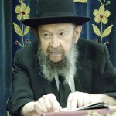

**QUESTION:** How does the greatness of the Chofetz Chaim compare to the greatness of the forefathers?

**ANSWER:** Now, in my little mind I can barely make a good comparison, but I’ll try. You’ll take a baseball and compare it to the size of the sun, that’s what it is. Avraham Avinu is the sun and the Chofetz Chaim is a baseball — a very good baseball.

Now, when we compare ourselves to the Chafetz Chaim, it’s like an atom compared to the baseball because the Chofetz Chaim was a very very great man. But the Chofetz Chaim compared to Avraham Avinu is only a baseball compared to the sun. Only that because we’ve never sufficiently studied the greatness of this great man Avraham so we think maybe it's an exaggeration.

Avraham Avinu kept the whole Torah קיים אברהם אבינו את כל התורה כולה עד שלא נתנה even before it was given. Look, Avraham Avinu had *dinim* of *sh’vuah*, laws of swearing oaths. Without the Torah being given he kept *dinim* of swearing. There were *dinim* of *nedarim;* וידור יעקב נדר. That family had *nedarim* already. Yaakov Avinu gave *ma’aser*, Avraham Avinu gave *ma’aser*, ויתן לו מעשר מכל – He gave *ma’aser* to Malkitzedek. *Ma’aser!* Avraham invented all these *dinim* by himself.

**Avraham Practiced Many Halachos**

**That are in the Gemara Today**

Avraham practiced many *halachos* that are in the *Gemara* today. When the family of Ya’akov took from the plunder of Sh’chem, and they took the idols too, so Yaakov told them to bathe and to also bathe their garments, because of *tumas avodah zara.* That’s not even an *issur de’oraisa! Tu*mas avodah zara is only an *issur d’rabanan.* Even *dinei d’rabanan* they practiced!

And all this came from Avraham Avinu’s great mind. Avraham invented so many things that are in the Torah that it’s amazing how he did such a thing – he was clairvoyant it seems, a magician. The answer is that he had a remarkable mind; he was the most brilliant, original researcher the world ever saw.

**The Talmidim of Avraham Avinu**

Moshe Rabeinu was not as original as Avraham Avinu. That’s why in *Pirkei Avos*all the people are called תלמידיו של אברהם אבינו, students of Avraham. Even Moshe Rabeinu is called a *talmid* of Avraham Avinu. We have no idea how great that man was.

Not only was he great but once he discovered the truth, he was stubborn to uphold the truth and he fought against his environment; his fought against his father and mother, his cousins, everybody! He fought against his whole environment and he refused to yield. “I know what’s right! I don’t care!” And even though it meant his life —his life was almost extinguished because of his stubbornness.

**Only Moshe Rabeinu Outdid Avraham**

And therefore this great man transcended any great person in our history. Moshe Rabeinu is the only one who outdid him, because Moshe Rabeinu was a special story. Moshe Rabeinu was given gifts from Hashem for the purpose of a special mission that the people should accept the Torah from his hands. So Moshe was a special creation.

But as far as originality – a man who with his own *kochos,* his own powers, his own gifts and talents became great, there’s no one like Avraham and like Sarah. We have to understand that. That’s why these two are the founders of our nation.

*Reprinted from the November 4, 2019 email of Toras Avigdor adapted from Tape #640.*

**Recognizing that the Entire**

**World was Created for the**

**Sake of the Jewish People**

**From the Talks of the Lubavitcher Rebbe**

**Rabbi Menachem Mendel Schneerson, Zt”l**

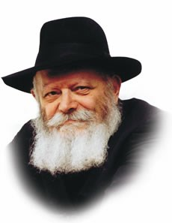

"And Abraham made a great feast on the day that Isaac was weaned," we read in this week's Torah portion, Vayeira.

"And Abraham was one hundred years old when his son Isaac was born to him... and Sarah said...'Who would have said to Abraham that Sarah would have nursed children?'"

**Rashi’s Explanation of the**

**Use of the Plural “Children”**

Rashi, the great Torah commentator, explains the use of the plural "children": "On the day of the feast, many princesses brought their babies to Sarah, and she suckled them. For they did not believe that she had actually given birth to Isaac, insisting that he was a foundling they had brought home from the marketplace. By nursing other babies as well as her own, Sarah demonstrated that she had indeed given birth. And she nursed them all," Rashi emphasizes.

What are we to learn from this narrative?

If Sarah's intent had been only to prove that Isaac was her biological son, would it not have sufficed for her to nurse him alone? Why does Rashi stress that Sarah "nursed them all"?

In answer, one must look at the global picture, and understand a seemingly radical concept: the entire world was created solely for the purpose of the Jewish people.

**Jewish People Became the Means Through**

**Which All of Mankind is Affected**

After the founding of the Jewish nation and the giving of the Torah, [The Jewish People] Israel became the means through which all of mankind is affected; no commandment from G-d can be conveyed to the world except through the Torah and Jewish people.

It is for this reason that the Seven Noahide Laws must be obeyed solely because G-d has so commanded, and not because one finds them intellectually compelling.

The Jewish nation's existence as a people commenced with the supernatural birth of Isaac, at which point its influence in the world began to be felt. The miraculous birth of Isaac therefore marked the beginning of an era of miracles and abundance for all of mankind.

**The Most Tangible Symbol**

The most tangible symbol of this occurred when Sarah was able to physically provide milk for the multitude of children who were brought to her to suckle, confirming the centrality of the Jewish people as the key to G-d's blessing.

"Many barren women were able to conceive; many sick were healed on that day [in Sarah's merit]," Rashi adds. "Many prayers were answered, and there was much joy in the world."

When Sarah "nursed them all," she demonstrated to the nations of the world that the Jewish nation had indeed been chosen and elevated by G-d.

**A Stunning Revelation After Moshiach Comes**

Similarly, when Moshiach comes, the exalted position of the Jewish people will be revealed and apparent to all, for it will be obvious that the nations of the world receive their blessings solely in the merit of the Jewish people.

*Reprinted from the Issue #339 of L’Chaim Weekly (Parashat Vayeira 5755/1994)*

**Rabbi Berel Wein**

**On Vayeira**

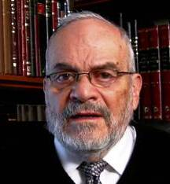

The Mishnah in Avot specifically, and Jewish tradition generally, instructs us that our father Abraham was constantly challenged with great tests in life and was able to survive and surmount all of them. There is an underlying difficulty to this narrative regarding the testing of Abraham.

G-d after all is omniscient and knows well in advance what the reaction of Abraham will be to all the challenges that are placed before him. This being the case, then one can easily ask why bother presenting those challenges in the first place.

This fits in to the general question that Maimonides deals with when he attempts to reconcile G-d's omniscience with the presence of human free will and free choice. His answer is that both exist and coexist and that is part of the secret of the fact that human beings and human logic can never truly understand the Infinite and the Eternal. So that is undoubtedly true in the case of Abraham and his challenges.

Even though ultimately we will be unable to arrive at a definitive answer to this question – almost all questions that begin with the word ‘why’ are never completely satisfactorily answered – nevertheless I believe that we can attempt to arrive at some sort of understanding as to the purpose of the tests that Abraham endured and overcame. The Torah would not have devoted so much space and such detailed descriptions to these events in the life of Abraham if there wouldn’t be eternal moral teachings present in the narrative that are relevant and true to all humans in all generations.

I think the obvious answer that jumps forth from the pages is that the tests are not meant to prove anything to Heaven as much as they are meant to prove the potential of greatness of Abraham to Abraham himself. It is our nature not to realize how great our potential is, how strong we really are, morally and emotionally, and to our surprise what we are capable of accomplishing.

It is one thing to profess that one has faith and is willing to make sacrifices on behalf of the preservation of that faith, whether personal or national. However, it is another thing completely to make those sacrifices, and to experience the emotional difficulties and even tragedies that life often visits upon us. A person never really knows what one's true makeup is unless tested over a lifetime, with the Talmud’s graphic phrase that we are ultimately tested regarding our final resting place.

Abraham becomes great and stands erect after having successfully dealt with the challenges to his faith and to his vision that life and the environment in which he lived set before him. That is perhaps what the Torah indicates to us when it says that Abraham's faith was of such power in nature that the Lord deemed it to be the paragon of righteousness. Righteousness is achieved only when challenges are overcome.

*Reprinted from this week’s website of Rabbiwein.co*

***More Thoughts that Count***

***For Parashat Vayeira***

"Laughter" refers to the supreme delight that will be revealed to the righteous in the World to Come. The Hebrew name "Yitzchak" ("he will laugh") is in the future tense, alluding to the time when this will take place. *(Torah Ohr)*

*Reprinted from the Issue #339 of L’Chaim Weekly (Parashat Vayeira 5755/1994)*

**Every Guest is Important**

**By Rabbi Eli J. Mansour**

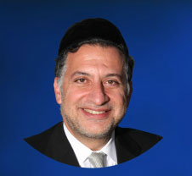

Parashat Vayera begins with the story of the three angels – who appeared as ordinary nomads – whom Abraham Abinu welcomed and hosted. The Torah describes at length the efforts Abraham expended on their behalf, personally serving them food and standing over them to care for them while they sat and ate.

We know from last week’s Parasha, Parashat Lech-Lecha, that Abraham had 318 servants. The question thus becomes why Abraham did not delegate the responsibilities entailed in hosting his guests to his servants. Why did he go through all the trouble to care for the three guests if he had a large team of workers to do so?

This point becomes especially noteworthy in light of the fact that Abraham was ninety-nine years old and had just undergone circumcision. He was obviously physically frail, and yet he made a point of personally tending to his guests.

It is explained that a host shows honor to his guests by personally tending to their needs, rather than asking his housekeeper or family members to do so for him. Hospitality entails more than simply providing the guests with their basic needs. It also requires making the guests feel at ease and feel respected. As such, it is important to not just ensure that their needs are cared for, but to personally involve oneself in this undertaking.

As mentioned, the three angels who visited Abraham appeared as simple nomads. Abraham did not think they were distinguished statesmen or great Rabbis. They were ordinary people. Even so, he insisted on giving them the respect of personally tending to them, rather than delegating this role to his servants.

Rav Avraham Pam (1913-2001) applied this lesson to the common situation of charity collectors. Often, when a collector comes to the door, we give a young child a bill and have him bring the money to the collector. While our motives are sincere – to train the child in the special Misva of charity – we fail to realize that this is demeaning to the collector.

A person who knocks on the door needs not only financial assistance, but also comfort and dignity. And we cannot fulfill this need unless we personally greet him and speak to him with respect. Rav Pam therefore urged people to bring their child with them to the collector when giving him money, rather than delegate the job to the child.

Children are very perceptive, and they note the difference between the way we welcome distinguished guests and the way we deal with others. It is important for them to see us show every visitor respect. If Abraham personally served three guests whom he thought were simple nomads, then we must likewise treat all people with respect and dignity.

*Reprinted from this week’s website of the Edmond J Safra Synagogue of Brooklyn website.*

**Thoughts that Count for Parashat Vayeira**

*And G-d appeared to him*. (Gen. 18:1)

When Rabbi Sholom DovBer (the fifth Chabad Rebbe) was four or five years old, he came to his grandfather, the Tzemach Tzedek, to receive a blessing on his birthday.

No sooner had he entered the room than the boy burst into tears. "Why are you crying?" the Rebbe asked his grandson.

"I learned in this week's Torah portion that G-d appeared to Abraham after he performed the mitzva of brit mila (circumcision). Why doesn't G-d appear to me too?" the young child wept in earnest.

The Tzemach Tzedek explained that when a tzadik, a righteous person, decides to circumcise himself at the age of 99, he is truly deserving of G-d's revelation!

From this story we learn the importance of educating our children in a true Torah way, till a fervent desire for holiness is developed and a sincere yearning for G-dliness is evinced.

Similarly, as we stand now on the threshold of the Messianic Era, our longing for the revelation of G-dliness in the world should be just as strong; we must also demand that G-d appear to us in His full glory with the Final Redemption.

*(The Lubavitcher Rebbe, Parshat Vayeira 5752) reprinted Issue #339 of L’Chaim Weekly (Parashat Vayeira 5755/1994)*

**The Shmuz onParshas Vayeira**

**The Prison Cell of Laziness**

**By Rabbi Bentzion Shafier**

**Founder of TheShmuz.com**

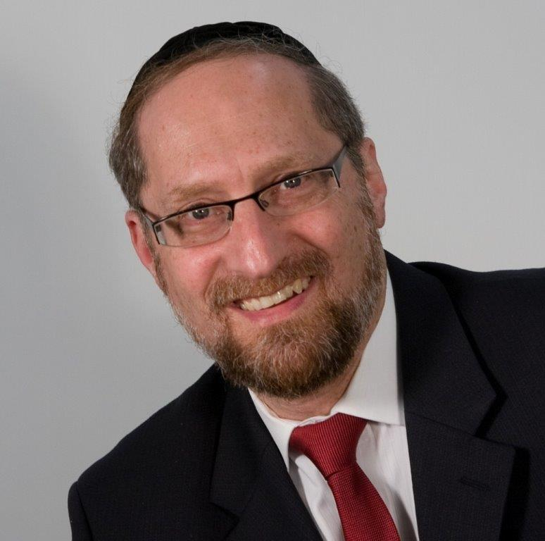

“*And he delayed, and the men held him, his wife, and his two daughters by the hand because of the mercy of HASHEM, and they took them and left them outside of the city.*” — Bereishis 19:16

HASHEM appeared to Avrohom and told him that the people of S’dom were wicked and would be destroyed. The only ones who would be saved were Lot and his family — because of the merit of Avrohom. HASHEM then sent two molochim, Gavriel and Michoel, to accomplish this task.

When they arrived on the scene, they explained to Lot that they were on a mission to wipe out the city, and he was to take his family and flee. Yet he didn’t move. “He delayed.” While he clearly understood the consequences, he remained glued to the spot. Finally, the molochim grabbed him by the hand and pulled him and his wife and his daughters away to safety.

The Siforno notes that there is an apparent contradiction here. It is clear that Lot was being saved because of the merit of his brother-in-law, Avrohom. Yet in this pasuk, it says that he was saved because of “the mercy of HASHEM.” Which one was it — the merit of Avrohom or HASHEM’s mercy?

The Siforno answers that both are true. Initially Lot was to be saved because of the merit of Avrohom. However, he wasted that opportunity. The molochim told him to flee and he didn’t. The merit of Avrohom was now used up. However, HASHEM still had mercy on him because “it wasn’t out of rebelliousness that he delayed, rather out of being overwhelmed by the situation and out of laziness.”

This Siforno is very difficult to understand. The two reasons given are: being **overwhelmed** and **laziness**. Aren’t these two concepts contradictory?

If Lot was “overwhelmed by the moment,” that means that he understood the gravity of the situation. The entire city — and every man, woman, and child in it — was going to be annihilated. Life as he had known it would cease to be. That understanding is enough to evoke terror in any man’s heart, and we can certainly understand why he didn’t move. He went into emotional overload. Too much was happening too fast. He froze out of fear.

But the Siforno said there was a second reason: laziness. If he was gripped by fear, how could he be too lazy to move? Is it possible that a man could be standing in a burning building, knowing that his life is in danger, and be too lazy to move?

To understand this we need a deeper perspective on the human personality.

**Understanding Laziness**

When HASHEM created man, He took two diverse elements and brought them together. One part of man is pure intelligence, the Nefesh Ha’Schili. The other part is animal instincts, the Nefesh Ha’Bahami. Together, these two make up the “I” that thinks, feels, and remembers.

The Nefesh Ha’Schili only wants to do that which is good, proper, and noble. It aspires for holiness and growth. More than anything, it desires to be close to its Creator. The Nefesh Ha’Bahami is made up of all of the instincts, drives, and passions in the human. Each part has its own nature; each has its own inclinations.

To better understand the animal soul of man, we need to look for its corollary in the animal kingdom.

**The King of the Beasts**

Living at the very top of the food chain, the mighty lion is known as the king of the beasts. You would imagine that his life would be idyllic, until you watch his daily routine. In the African Serengeti, the male lion will wake up in the noon sun, let out a monstrously loud yawn, roll over and go back to sleep.

A few hours later, he will wake up for bit, and then go back to sleep again. Not long after that, he will stir, let out another earth-shaking growl, and go back to sleep yet again. On average, he will sleep twenty hours a day. When there is no food to eat and the pride is not under not under threat, there is a heaviness to his nature that is almost depressing to watch.

Part of the human has that tendency. We know it as laziness, but it is actually a sluggishness that is part of his inner nature. As the Mesillos Yesharim describes it: “The nature of physicality is thick.”

There is a part of me that just doesn’t want to move. It is a weightiness that makes we want to just stop and remain inactive — not out of tiredness, not out of fatigue, but because of a lazy streak that makes me just wants to vegetate.

Even when a man may is fully motivated and driven to perform, this tendency can remain in the background and surface in almost undetectable ways influencing his actions and decisions.

**Two Forces in Lot**

This seems to be the answer to the Siforno. Lot was fully aware that the molochim came to destroy S’dom, and because of that, he was in a state of extreme agitation. “Oh, my goodness! The entire city with everyone in it will be destroyed!” Yet at the same time, there was a heaviness that influenced him. While he understood the gravity of the situation, he was still pulled by the heaviness of physicality, and when there was a decision to be made — do I leave or do I stay? — both elements had their say.

He was indecisive because he was overwhelmed, but in the background, without his being aware of it, was also a sluggishness that made it even harder to choose. The chiddush that we see from this Siforno is that laziness will surface and factor into the equation even under such grave circumstances.

**Laziness in our Lives**

The concept is very helpful in understanding the dynamics of the human personality. It is almost unheard of that a single trait will drive a person’s behavior. Typically, there are multiple forces at work: some good, some bad, and some just nature. Within our actions, there may be many factors that weigh and shape the way we operate. While we may think that the reason we aren’t producing enough is that we aren’t sufficiently motivated, it may also be a simple dose of laziness.

Held down by metal chains, tied to a ball of heavy iron, the lazy man can’t move. Everything is difficult; everything is a burden. Even the greatest motivation won’t get him to move. Lot could not have been more motivated to act. He was distraught because he understood that his very life and the life of his city was at risk, yet laziness factored in and prevented him from moving.

For a person to reach his potential, it isn’t enough to be motivated to do the work necessary; he must attack this middah directly. When he does, HASHEM will help him to acquire the opposite: the middah of alacrity, so he can change his very nature and become the great individual he was destined to be.

*Reprinted from this week’s website on TheShmuz.com This is an excerpt from the [Shmuz on the Parsha book](https://theshmuz.com/product/shmuz-on-the-parsha-book/).*

**In Chicago, Reclaiming Jewish Identity through**

**Adult Circumcision**

**By** [**Menachem Posner**](https://www.chabad.org/search/keyword_cdo/kid/12145/jewish/Posner-Menachem.htm)

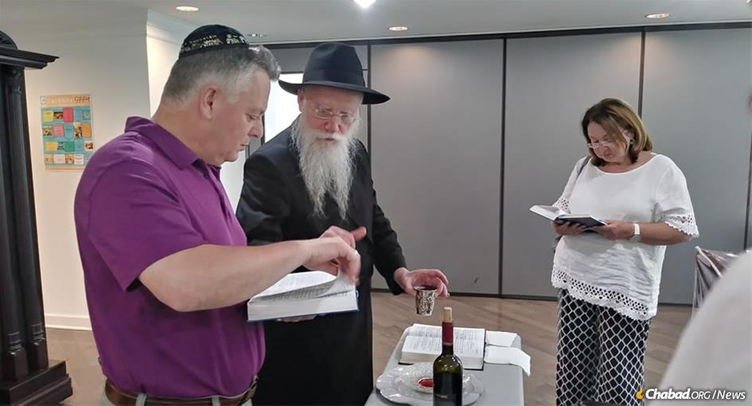

Rabbi Shmuel Notik makes the traditional blessings as Ilya, who was born in the Soviet Union, is given a Hebrew name Yosef Yitzchak Meir, following his brit milah. Yosef Yitzchak Meir's wife, Alina, looks on.

Standing in the sun-drenched sanctuary, large windows showing manicured lawns framed by verdant shrubbery, we could just feel that something special was happening.

In the floor above us, a [circumcision](https://www.chabad.org/library/article_cdo/aid/4160682/jewish/20-Facts-About-Jewish-Circumcision-Everyone-Should-Know.htm) was taking place. After nearly 60 years of life, Ilya would soon fulfil the first mitzvah given to Abraham, finally claiming the Jewish heritage that had been his all along.

Rabbi Shmuel Notik, who directs F.R.E.E., the Russian Jewish community of Chicago and Suburbs, says he facilitates an adult circumcision every few weeks, usually a Soviet-born male between the ages of 40 and 80, who has chosen to enter into the Covenant of Abraham.

“In the early ’90s when people were streaming out of Russia by the thousands, we would have as many as 10 circumcisions a week,” recalls Notik, who was born in Moscow and raised in the clandestine Chabad-Lubavitch underground community in Samarkand before emigrating to the United States as a teen. “Several years ago, we began a campaign to provide circumcisions for those who didn’t do it when they first arrived, and we now have, thank G‑d, another circumcision or two every few weeks.”

All told, he estimates that 6,000 Jewish men and boys have been circumcised through his organization.

While Ilya was being operated on, his wife, Alina, shared their life story.

She told how her father had become a member of the Communist Party in order to become a factory manager in her hometown of Bender, then part of the Soviet Union, now in the contested area of Moldova claimed by the mostly unrecognized state of Transnistria. Yet, even his professional accomplishments were not enough to secure his daughter a spot at university in a system that discriminated against Jews.

With no recourse, at the age of 17, she traveled to Kharkov in Soviet Ukraine to further her education. And it was there that she met Ilya, one year her senior.

Like her, Ilya was Jewish (his great-grandfather had been a well-known [rabbi](https://www.chabad.org/library/article_cdo/aid/1933944/jewish/What-Is-a-Rabbi.htm) of Kharkov, author of the ethical work, *Shem Tov,* Vilna, 1913), but he knew little about his heritage other than the fact that he was different. Alina said her parents always made sure to get [*matzah*](https://www.chabad.org/holidays/passover/pesach_cdo/aid/661092/jewish/What-Is-Matzah-Matzo.htm) for [Passover](https://www.chabad.org/holidays/passover/pesach_cdo/aid/871715/jewish/Passover-2019-Pesach.htm), and celebrate with honey strudel and attend synagogue on [Rosh Hashanah](https://www.chabad.org/library/article_cdo/aid/4644/jewish/Rosh-Hashanah.htm). It could have cost them their careers, but they took that risk and did what they could.

They pair felt an instant kinship and, after several years of courtship, decided to marry. In a dramatic story that spanned three decades and three continents, the two parted ways, married, had children with their respective spouses, divorced and reunited. By that time, her family was in Israel and his in Chicago. To further complicate things, he knew no Hebrew, and she knew just a little English.

But they finally accomplished their dream of building a home together in Chicago.

**‘Every Jewish Milestone Should Be Celebrated Beautifully’**

We interrupted our conversation when the rabbi came down to inform us that the bris had been completed. As Notik and [*the mohel*](https://www.chabad.org/library/article_cdo/aid/145142/jewish/What-Is-a-Mohel.htm) heartily congratulated Ilya with lively calls of *[mazal tov](https://www.chabad.org/library/article_cdo/aid/160965/jewish/What-Does-Mazel-Tov-Mean.htm" \o "What Does \"Mazel Tov\" Mean?),* he smilingly told his wife that he was feeling great.

Then, holding a cup of wine, the rabbi recited the traditional blessings, including the prayer in which the celebrant was given his new Hebrew name, Yosef Yitzchak Meir, after his two grandfathers: Yosef and Yitzchak Meir. Yosef Yitzchak, the rabbi pointed out, was also the name of the[Sixth Chabad Rebbe](https://www.chabad.org/library/article_cdo/aid/110174/jewish/Rabbi-Yosef-Yitzchak-Schneersohn.htm), who had battled valiantly for the survival of [Judaism](https://www.chabad.org/library/article_cdo/aid/3710122/jewish/What-Is-Judaism.htm) during the darkest days of Stalinist oppression.

We then proceeded to the adjoining room for the traditional festive meal, and I was struck by how elegant it all was. It turned out that Shternie Notik, who has been spearheading FREE together with her husband since 1981, puts special emphasis on celebrating the circumcisions in a most appealing fashion. “Every holiday or Jewish milestone should be celebrated beautifully,” she says, “and especially when an adult Jew reclaims his identity by having a bris. We make sure that a special feeling pervades the entire event, and over time, that itself has inspired many of the guests to go ahead with their own circumcisions.”

As we feasted on an abundance of steak, turkey breast, challah and salads, the rabbi shared that he recently facilitated a circumcision for an 84-year-old man, along with his son and his grandson. Another man at the celebration, David, used the Russian term *maladets*, “hero,” to describe the men who undergo circumcision in adulthood.

“In my experience, everyone eventually comes around and does the circumcision,” asserts the *mohel*, Rabbi Levi Heber, who flies to Chicago from New York once or twice a month to perform circumcisions. “The Jewish soul is deeply connected to this mitzvah, and that comes through.”

The conversation flowed naturally between Russian, English and Hebrew.

Having lived in Kharkov until 1995, when he came to the United States for work reasons, Yosef Yitzchak Meir heaped high praise on Rabbi Moshe Moskovitz and his fellow Chabad rabbis in Kharkov, who have rebuilt Jewish life in the city, which has approximately 30,000 Jews. One of his sons, then a student in the Chabad preschool in Kharkov, was circumcised as a child.

“My parents don’t know about my *bris* yet,” he continued. “They survived the Holocaust by escaping Kharkov until the Russians beat back the Nazis and lived most of their lives under the Communists, and they are still afraid.”

Notik is no stranger to observing Judaism in spite of danger. His grandfather perished in Soviet prison for the “crime” of upholding Judaism, and he vividly remembers the fright his family experienced when a drunk banged on their door late one night. They were sure the secret police were coming for them, too.

In true Russian Jewish fashion, the meal was punctuated with frequent “*[lechaims](https://www.chabad.org/library/article_cdo/aid/2987145/jewish/Why-Do-Jews-Toast-LChaimTo-Life.htm" \o "Why Do Jews Toast L’Chaim—To Life?)*” in which blessings were heaped upon those present, their families and anyone else. The blessings for the rabbi included wishes that he soon succeed in procuring the funds to build a new community center—one that would be the pride and joy of the entire Russian-speaking Jewish community in the area.

“The Russian culture is very rich and very strong,” the rabbi explains, “and even children born in America still identify as Russian Jews. They enjoy Russian cuisine, Russian literature, playing chess and everything that they got from their parents.”

**‘The Feeling of Coming Home’**

**Celebrating the brit Milah.**

A big part of that culture, I learn, is celebrating milestones like this one in an unhurried fashion. As a very occasional drinker, the extra Scotch was beginning to have its effect on me, but I couldn’t leave until I had completed my interviews.

As we concluded, the *mohel,* who had a few minutes before David would take him to the airport,told me how he was exposed to the world of circumcision. “In 1990, I went to Moscow to serve as head counselor in the Jewish summer camp,” he recalls. “We knew very little Russian and the kids knew virtually no English, but they so wanted to embrace Judaism.”

With just poor Soviet-era anesthesia, boy after boy committed to undergo circumcision—no easy feat for a young man entering adolescence. “They saw how we lived as Jews, and they wanted it for themselves.”

Upon returning to America that fall, Heber observed how circumcision was being done for the many Russian Jews then arriving in New York. He returned to Moscow the following summer with state-of-the art anesthetics, sutures, fine needles and medical know-how, which he passed on to the longtime *mohel* of Moscow, Avrohom Genin.

Today, he has the pleasure of performing circumcisions on the sons of his erstwhile campers, seeing how the seeds of Judaism planted nearly three decades ago have grown into vibrant family trees.

Even though he has performed thousands of circumcisions—sometimes in three states in a single day—he says that each one is special, especially when it involves an adult. “There is the feeling of finally coming home, fixing something that has been waiting to be corrected all along.”

*Reprinted from the Parashat Vayeira 5780 email of Chabad.Org Magazine.*